Read comments from previous graded work.
Read all the comments on the graded post labs. Implement the changes suggested from the comments into your current work.
Format (These are general rules that apply to all post labs and lab reports. Use the rule(s) that apply to your specific content)
- The goal is to tell your story as briefly as possible.
- Use third person with past tense, passive voice, 12-point font, single spaced. When discussing theory, you may use present tense. Do not indent the start of each paragraph but give an extra space between paragraphs.
- Keep figure titles left justified, with figures small (but legible) and centered. Figures MAY NOT span more than one page. Ideally a table should fit on one page or less.
- Figure titles should be BELOW the figure and should be formatted as follows: Figure 1. Figure Title. Table titles go above the table and are formatted as follows: Table 1. Table Title. Scheme titles go above the scheme and are formatted as follows: Scheme 1. Scheme Title.
- Be sure to introduce figures, tables and schemes in the text before inserting them into the paper.
- Annotated spectra and sample calculations go in an appendix. If you have annotated spectra and sample calculations you would have two appendices. each appendix has a title with this format. Appendix Letter (start with A). Appendix Title. If multiple appendices, spectra are first. Annotated spectra are figures and need a figure title. If you have one appendix, figure numbers would be 1A, 2A, 3A ... If you have multiple appendices figure numbers in the first appendix would be 1A, 2A, 3A...and figures numbers in the second appendix would be 1B, 2B, 2C...and so on for each following appendix. IR spectra are presented as two to a page in portrait mode and NMR spectra are one to page using landscape mode.
- Be concise and use correct spelling and grammar.
- Upload a PDF document of your laboratory report. Guidelines for the individual sections are shown below. The guidelines are not all encompassing. These reports require critical thinking that demonstrate mastery of the material. Spectral annotation guidelines are located on the spectroscopy module page.
Helpful hints:
1) Read all the comments on the graded post labs 1-3 that you uploaded. Implement the changes suggested from the comments into your current document. Not incorporating suggestions from the comments will cost you points. Copy and paste post labs 1-3 into a new document. Make sure to assign each part of the post labs to the appropriate section in your report. i.e. discussion of what solubility is, and how it is used in QA goes in the introduction; while the figure and discussion of the solubility of your unknown would go in results and discussion.
2) Your paper should have the following sections in the order presented below. Use the section names we are giving you. Spelling, grammar, punctuation, and formatting count. The points for each are in parentheses.
Upload a PDF document that includes the following:
Content:
Type the following for the header (2 point)
CHEM 3418 Section XYZ
Your Name
(Fall, Spring or Summer) 20XX
Title
Don't forget to create a running header with your last name and the page number starting on page 2 of your report. Talk to your TA during office hours if you need help learning how to do this in word.
Abstract (3 points)
Abstracts are always short (250 words or less) paragraphs that tell the reader an overview of what they are about to read. This will include the purpose of the experiment (without saying the purpose of this experiment was), what techniques were used to accomplish this, and the main conclusions. We are giving this to you for your first report. Copy and paste the following, make sure you change the variables to match your information/data.
Unknown X was determined to be ABC (put IUPAC name of compound instead of ABC) and unknown Y was determined to be DEF (put IUPAC name of compound instead of DEF) through solubility testing, physical properties, functional group testing and derivative formation. Fourier transform infrared (FTIR) spectroscopy of the unknowns were used to confirm the functional groups of the unknowns.
If you were not able to determine the exact identity of an unknown, then present the list of possibilities based on your data.
Introduction (19 points)
The introduction should give the reader background information on anything they might need to know in order to understand your results. This is generally a fairly short section. This may include techniques used, prior research, mechanisms of the reaction, and more. You may mention specific tests, techniques, etc. that you used in the experiment, and what they are for, but you stay away from any sort of results. Never include procedural details.
Write a brief paragraph introducing the topic of qualitative analysis as a means to identify unknown organic compounds. DO NOT say “the purpose of this lab….” Then take the introduction sections from each of your post labs and put them in this section. You now have an introduction to solubility, melting point, boiling point etc. These short paragraphs also give the reader a brief description of how these techniques work. Do not forget to add paragraphs introducing functional group testing, derivative formation, and FTIR. Don't forget what aspects need to be an introduction. What background knowledge does the reader need to understand your results? What does each technique or test do? How does it help us identify the unknown? Do not make this section one giant paragraph.
Results and Discussion (46 points)
Results and Discussion are pretty straightforward. State what technique was used to gather your results, present your results in the most elegant, yet concise way possible, then discuss them. The common mistake is to just present your results and move on. Remember, it is called results and discussion. You must always discuss why these results are important, what do they mean.
Place the paragraphs from the three post labs that directly discuss the results you obtained. You have already written these paragraphs. The order is the same as the order you did the labs in. Physical presentation of both unknowns. Solubility results and conclusions for both unknowns. Melting point of the solid unknown and mp of the recrystallized solid unknown, bp of the liquid unknown and conclusions for both unknowns. Functional group test results for each unknown, derivative formation results for each unknown, and FTIR results for each unknown. Finally state what the identity of each unknown is and include a figure that shows the structures of the two unknowns. The figure should be centered across the page. The actual drawing part does not have to be too big. The title is Figure 1. Structure of A, X; Structure of B, Y. The figure title is left justified. In the figure each structure should be labelled A or B. In the title X and Y are unknown # for each of the unknowns.
Here is an example of what your table should look like for your functional group test data. Remember to always call out the important results, introduce the table, insert the table (with title), then remark on the conclusions (discussion) from that table.
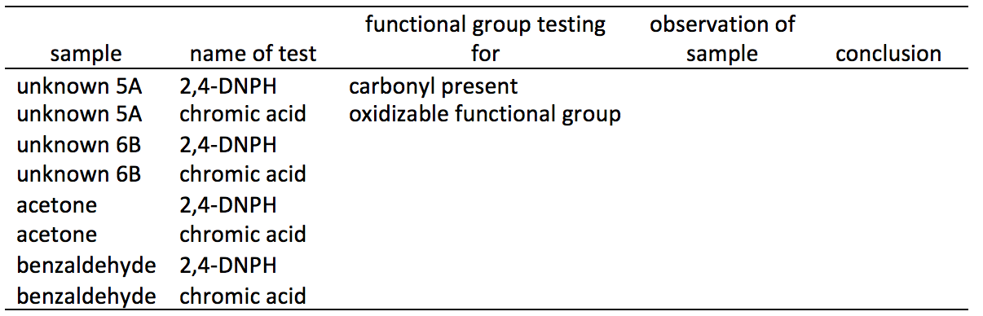
You can now narrow down the list of unknowns from the BP/MP even further. Create a table to show the narrowed down possibilities, this should be a narrowed down list from your MP/BP table. Remember, you cannot start a paragraph with a table or a figure which is why we start with text then insert the table. You should never have tables or figures next to each other without text in between them. What conclusions can be drawn from this table?
The column headers for your derivative table should look like the table below. Choose either mp or bp for the headers depending on whether the unknown is a solid or a liquid.
Functional Group | Type of Derivative | Melting Point Range of Obtained Derivative (ºC) | Literature Melting Point Range of Obtained Derivative (ºC) | Possible Identities of Unknown | Literature Melting Point Range of Unknown (ºC) | Experimental Melting Point Range of Unknown (ºC)
The list of possible compounds should be a sub set of the ones from your R-group table.
Your FTIR tables should look like the one shown below as an example. The format for reporting spectral data is very specific. Wave numbers for the band (either the apex wavenumber of the band or a range of wavenumbers) and the bond associated with the band. The left column should contain the structure of the compound. The wavenumbers you insert will be those that are on your individual FTIRs that you took in lab, they will NOT be the ranges you find in your textbooks. Notice that wavenumbers are ranges for very broad bands and single numbers for sharp bands. Always introduce a table before inserting it, do not forget that each table should have a table title.
Compound | FTIR Band (cm⁻¹)
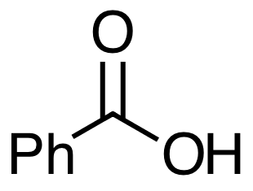 | 3400-2500 O-H stretch  3100 sp² C-H stretch  1700 C=O stretch  1500,1600 C=C stretch (in ring)
Conclusion (5 points)
Summarize your conclusions from the results and discussion. This is really just a brief restatement from your results and discussion. Make sure to point out any major points that supports the identity you have determined for each unknown. Include specific data (i.e. mp values, etc).
Experimental (2 Points)
We are going to give you this section as well. Write in the following text and leave out the quotes:
"The University of Colorado Chemistry Department provided all chemicals. All procedures were adapted from the cited materials by the University of Colorado at Denver Chemistry Department." ¹ FTIR spectra were obtained with a Nicolet iS5 FTIR spectrometer and all measurements were in cm⁻¹.
You do not have to write up the procedures unless you made significant deviations from what was stated in the modules.
References (3 points)
Add in any references that you used. Use superscripts in the text and cite the reference in this section. The source of the procedures and lists of unknowns that we used is cited below. The format for citing websites is shown in the second citation. Make sure you add the correct access date (the date you actually looked at that website). You will all have reference 1. Other references will be based on what you individually used.
1. Pavia, D. L., Lampman, G. M., Kriz, G. S., Engel. R. G. Introduction to Organic
Laboratory Techniques: A small scale approach,1st ed.; Saunders College Publishing: Belmont, 1997.
2. Spectral Database for Organic Compounds, SDBS. http://riodb01.ibase.aist.go.jp/
sdbs/cgi-bin/direct_frame_top.cgi (accessed Feb. 19, 2012).
Appendix (10 points)
Make sure to have a title.
Insert the IR spectrum of each unknown. Use portrait mode for the spectra. You should be able to get two spectra on one page. Do the annotation on the spectrum in Powerpoint. Group everything at the end and make one group then copy and paste into Word. The structure of the unknown needs to be drawn on the spectrum as part of the annotation. All non-fingerprint bands need to be identified and labeled. The label is the type of bond causing the band and have an arrow that CLEARLY shows which band you are attributing the annotation to. Each spectrum is a figure and needs a figure title. Make sure to follow format guidelines as seen at the top of each assignment page.
Spelling, grammar and format (10 points)
1 point deduction for each error.

Rubric
Unknown Lab Report (1)
Unknown Lab Report (1)
Criteria | Ratings | Pts
This criterion is linked to a Learning OutcomeHeader |  | 2.0 pts
  2.0 pts  Present and exactly as shown in instructions | 0.0 pts  Not present
This criterion is linked to a Learning OutcomeAbstract |  | 3.0 pts
  3.0 pts  Concise, makes sense, all needed material present. | 0.0 pts  Not present
This criterion is linked to a Learning OutcomeIntroduction |  | 19.0 pts
  19.0 pts  Excellent understanding of the material. | 0.0 pts  Not present or not complete
This criterion is linked to a Learning OutcomeResults and Discussion |  | 46.0 pts
  46.0 pts  Concise. Excellent connections between the results and discussion. | 0.0 pts  Not present, too many mistakes
This criterion is linked to a Learning OutcomeConclusion |  | 5.0 pts
  5.0 pts  Complete, has all elements and no grammar/spelling issues | 0.0 pts  Incomplete and/or missing
This criterion is linked to a Learning OutcomeExperimental |  | 2.0 pts
  2.0 pts  Present exactly as in instructions | 0.0 pts  Not present or not exactly as in document
This criterion is linked to a Learning OutcomeReferences |  | 3.0 pts
  3.0 pts  Present and is has all necessary cited material here | 0.0 pts  Large mistakes and/or not present
This criterion is linked to a Learning OutcomeAppendix |  | 10.0 pts
  10.0 pts  Both spectra are annotated correctly | 0.0 pts  Not present or too many missing
This criterion is linked to a Learning OutcomeSpelling, grammar, format |  | 10.0 pts
  10.0 pts  No errors | 0.0 pts  Too many errors
Total Points: 100.0

